Term |  | Autumn 1 | Autumn 2 | Spring 1 | Spring 2 | Summer 1 | Summer 2
Umbrella Topic |  | Marvellous Me  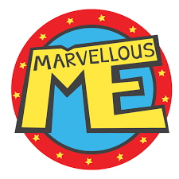 | Let’s Celebrate   | Traditional Tales  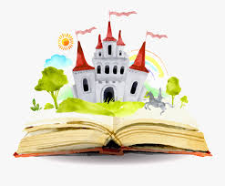 | On the Farm  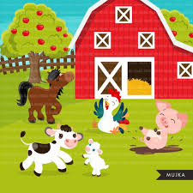 | Under the Sea  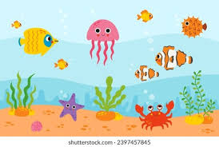 | Magnificent Mini-Beasts  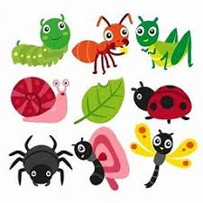
Enquiry question (P4C) |  | What would you like to know about me? | How do we celebrate? | What makes a good story? | What will we see at the farm? | What lurks beneath the sea? | Is change bad?
Hook and Celebrations |  | Transitions - Starting School | Nativity Performance | Fairytale Feast | Farmyard dress up day | Message in a bottle | The Bug Ball
Off site visits and Enrichment opportunities |  | Sensory walk around the school grounds | Post Box Walk | Open box theatre workshop | Visit to Staunton Farm | Visit to Blue Reef | Visit to the Nature Reserve
Key Texts |  | • Our class is a family  • This is me!  • Living with mum and living with dad  • In my Heart  • You Choose  • From Head to Toe  • Super Duper You | • Festivals!  • Little Glow  • You Must Bring a Hat  • Kipper’s Birthday  • The Scarecrows Wedding  • The Jolly Christmas Postman  •The Christmas Story | • The Three Billy Goats Gruff  • Goldilocks and the three bears  • The three little pigs  • Jack and the Beanstalk  • Red Riding Hood | • Farmer Duck  • What the ladybird heard  • The Little Red Hen  • A squash and a squeeze  • The Enormous Turnip  • On the Farm | • Tiddler  • Rainbow fish  • The Pirate Mums  • The Snail and the Whale  • Somebody Swallowed Stanley  • Commotion in the Ocean | • Mad about Minibeasts!  • The Big Bad Bug  • The Very Hungry Caterpillar  • Super Worm  • Spy der  • The Hotel for Bugs
Literacy Topic |  | All About Me | Celebrations | Story Telling | All about the Farm | Sea Creatures | Mini-beasts
 |  | Refer to Medium Term Planning.
Phonics – Little Wandle |  | Phase 2 | Phase 3 | Phase 3 | Phase 3 | Phase 4 | Phase 4
Maths |  | NCETM Planning
PSED |  | My Happy Body –  Managing their own personal hygiene needs.  Know and talk about the different factors that support their overall health and well-being: regular physical activity, healthy eating, teeth brushing, sensible amounts of ‘screen time’, having a good sleep routine, being a safe pedestrian. |  | My Happy Relationships –  Build constructive and respectful relationships. Continue developing positive attitudes about the differences between people. Express their feelings and consider the feelings of others. Show resilience and perseverance in the face of challenges. Identify and moderate their own feelings socially and emotionally. Think about the perspectives of others |  | My Happy World –  Name and describe people who are familiar to them.  See themselves as a valuable individual.
Physical Development |  | Hand Gym – Fine Motor Activities  Dough Disco  Get Set 4 PE – Introduction to PE | Hand Gym – Fine Motor Activities  Dough Disco  Get Set 4 PE – Fundamental Skills | Hand Gym – Fine Motor Activities  Dough Disco  Get Set 4 PE –  Ball Skills | Hand Gym – Fine Motor Activities  Dough Disco  Get Set 4 PE – Games | Hand Gym – Fine Motor Activities  Dough Disco  Get Set 4 PE – Dance | Hand Gym – Fine Motor Activities  Dough Disco  Get Set 4 PE – Gym
Understanding The World | Links to History | My Family – Exploring our family photos and traditions | Routines and Celebrations – Exploring the concept of time through personal and family celebrations, chronology. | Traditional Tales – Exploring the past through stories | Farming Life – Past and Present, exploring how farming has changed over time | Changes to the seaside – Explore during the aquarium Visit | Lifecycles – Long term changes
Understanding The World | Links to Geography | My Local Community | Christmas Around the World | Maps of our local area | The Farm – Physical and Human geography | Where is the sea near us | Habitats
Understanding The World | Links to Computing | Introduction to Technology  Exploring technology in the classroom  Using simple apps (paint, camera) |  | Exploring technology in the classroom  Online safety and risks: using the internet, reporting worrying things and keeping passwords safe |  | Introduce programmable toys – Vex123 Robot  Begin using simple programmes  Create routes for Vex123 robot
Understanding The World | Links to Science | Identifying body parts and exploration of senses | Exploration of light and dark | Exploration of natural materials – What material would be best to build a house? | Identifying and naming a range of different animals and their offspring | Floating and Sinking | Living Things and Habitats
Understanding The World | Links to Science | Seasonal Changes
Expressive Arts and  Design | Music | Little Wandle Rhyme time | Little Wandle Rhyme time | Little Wandle Rhyme time | Listen attentively to music noticing changes in pitch, tone and rhythm. | Explore and experiment with musical instruments, sounds and movement. | Create and perform musical expressions for ‘The Bug Ball’
Expressive Arts and  Design | EAD | Colour Mixing  Self Portrait Malleable Materials Role-play | Christmas Decorations  Diwali Lamps  Nativity Collage Role-play | Puppets  Making Pancakes and Porridge  Creating a giant beanstalk  Designing Bridges and Chairs  Role-play  Chinese New Year Arts and Crafts  Valentines’ cards | Small World Props  Observational drawing of a turnip  Farm animal masks  Bread Making | Under the sea collages  Under the sea movement to music  Role-play | Creating own Minibeasts habitats  Bug Hotels  Creating hats for the Bug Ball  Role-play
Expressive Arts and  Design | Artists | Jackson Pollock |  | Piet Mondrian |  | Kenn Done
RE |  | Belonging - All about Me | Celebration - Celebrating the birth of Jesus –The Nativity Story - Christianity | Special - Special Clothes  - Christianity and Hinduism | New Life - New Life at Easter Story  - Christianity | Remembering – The importance of Krishna’s Birthday - Hinduism | Looking Forward - Transition
SMSC / British Values | Values and Attitudes | Appreciation of own environment and living things.  Sense of identity and self-worth. Sense of wonder and curiosity. Class Agreement. | Concerns for others in immediate circle. Sense of fair play | Sense of wonder and curiosity. Willingness to admit to and learn from mistakes. | Appreciation of own environment and living things.  Positive attitude towards difference and diversity. Sense of wonder and curiosity. | Appreciation of own environment and living things. Positive attitude towards difference and diversity. Sense of wonder and curiosity. | Appreciation of own environment and living things. Sense of wonder and curiosity.
SMSC / British Values | Knowledge and Understanding | Sense of immediate and local environment. Awareness of different places | What is fair/unfair. What is right and wrong. | Our actions have consequences | Living things and their needs How to take care of things. | Awareness of others in relation to self. | Awareness of similarities and differences between people. Living things and their needs How to take care of things. Sense of the future.
 | Skills | Listening to others Sharing Starting to participate | Asking questions Beginning to identify unfairness and take appropriate action. | Asking questions Beginning to identify unfairness and take appropriate action. | Asking questions Beginning to identify unfairness and take appropriate action. | Co-operating Starting to look at resolving arguments peacefully | Beginning to take care of things – animate and inanimate.
Cultural Links and Celebrations  (Options to do as well as RE specific, based on beliefs of children in class and embedding a tolerant society for all) |  | Harvest 1 -23 October  Yom Kippur  Sukkot  Halloween 31st October  Diwali  Bonfire Night 5th November  Remembrance Day 11th November  Christmas 25th December |  | New Year 1st January  Chinese New Year  Valentine’s Day 14th February  Shrove Tuesday  Mother’s Day  Eid Al – Fitr  Easter Sunday |  | May Day May 1st  Walk to School Week  Father’s Day  Eid-Al-Adha

